CrowSoft

Sprint 0

Architecture & Design

Version 1.1

By Charles Aylward

(Updated: 04/05/2019)

Sprint 0

LYIT – DevOps Project Management

# Vision

The customer would like an on-line system to take in building details for analysis. CrowSoft is an engineering and tech company. The product that they wish to market is BusIntelligence. The system must take details for buildings and to provide easy to use analysis features. For example, they may wish to have a review all buildings which cost more than €1 million to build and have special features as this may indicate future maintenance projects that may be exploited. Keep the analysis simple. The analysis system should be clean and simple. The system needs to take into account the usual details and present simplified graphics. It must be possible to upload files or images. The administrator should be able to access detailed information and edit as appropriate. Once the client enters details it should not be able to be changed by the client.

The following are CrowSoft’s main goals:

1. Defining overall Agile and DevOps processes, including scrum roles (Refer to : CrowSoft Agile DevOps Processes - Draft.docx in Documentation on GitHub)
2. Define and select tools and infrastructure requirements for CI/CD pipelines
3. Setting up environments for development, staging and production, including DevOps tools required for the complete pipeline
4. Create product backlog for the Business Intelligence Solution by having sprint planning / requirements meetings with the Product Owner
5. Develop and deploy the new Business Intelligence Solution within 10 sprints

# System Context Diagram

As per functional requirements, the following depicts a high level context diagram showing interactions between the new system and actors.



# Conceptual Solution Architecture

1. The following features is required:
   1. The system will be access via a web browser
   2. Security will be implemented by giving customer the ability to create a new account and login details and admin users to manage all users of the system.
   3. The system will automatically complete a cost analysis and display costing to the customer
   4. The system should notify the admin user when costs exceed €1 million.
   5. Functional and non-functional requirements: **(*Refer to: CrowSoft functional non functional requirements.docx in Documentation on GitHub*)**
2. Architecture and development decisions:
   1. Collaboration / Scrum tool using Jira
   2. Performance management tool
   3. Unit test tools (Nunit)
   4. Communication using Slack
   5. Jenkins for Continuous Integration
   6. Artifactory for library management
   7. ~~NixOS~~ Ubuntu 16.04 Linux for development, staging and production servers
   8. Ansible for configuration management
   9. MySQL database
   10. C# language with .Net Core libraries (VSCode or VS Community Edition)

Figure - Conceptual Architecture Diagram

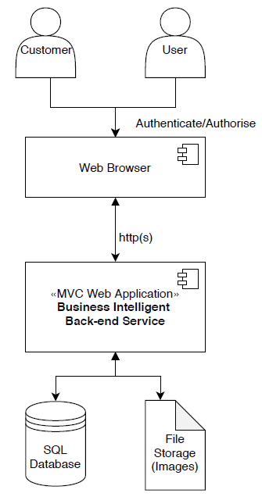

# Software Technology Stack

Below find the proposed software technology stack for the main solution:

* Server(s)
  + OS: Ubuntu 16.04 Linux Server
  + Regions: CI/CD Server, Development, Staging and Production
  + 80GB Storage, 8GB Ram, 8 cores
* Web Browser: Chrome, FireFox, Safari, etc.
* Language: C#
* IDE :Visual Studio Code or Visual Studio 2017 Community Edition
* .Net Framework:.Net Core 2.1
* Web Server: Kestrel (open source, cross platform, light weight and a default web server used for Asp.Net Core applications.)
* Application Code: MVC Web Application
* SQL Database: MySQL
* Directory: To store images
* Unit Testing: Nunit
* Logging: log4net
* Code Quality: Visual Studio Code Analysis (Included in IDE)
* Security: OAuth **(TBD)**

Figure - Software Technology Stack

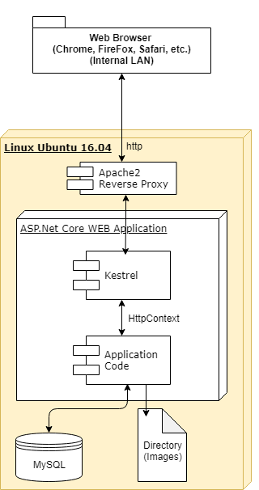

# Infrastructure Requirements

